MasterCard Personal Expense Management System (MPEMS)
Use Case Model Survey
Filing Reference : | MPEMS_T-1.3.1
Document Title : | User Interface Design
Version : | 0.1
Prepared By : | LEE ZHONG DE ROLLEI
Date Created : | 18 Apr 2012
Review By : | Huang Dong Hao
Revised Date :

Revision History:
©1993 ISS.  The information contained in this document is the property of ISS. The contents must not be reproduced, wholly or in part, for purposes other than for which it has been supplied, without the prior permission of ISS, or, if it has been furnished under contract to another party, as expressly authorised under that contract. ISS shall not be liable for any errors or omissions. | ISS

Version | Date | Author | Remarks
v0.1 | 18 Apr 2012 | - LEE ZHONG DE ROLLEI | Initial Draft

Distribution:
Name | Department | Organization
Huang Donghao | MasterCard | MasterCard
Dao Xuan Dung | S2 | ISS
Lee Zhong De Rollei | S2 | ISS
Alvin Lee | S2 | ISS
Guo Yu | S2 | ISS
Zhou ZiFeng | S2 | ISS
Jiang Hao Min | S2 | ISS

1. Introduction 4
1.1 Project Client Background 4
2. Member Screens 5
2.1 Login 5
2.2 Dash Board 5
2.3 My Profile 5
2.4 Transaction 5
2.5 Reports 5
2.6 Budget Setting 5
2.7 Rewards 5
2.8 Exclusive Deals 5
3. Administrator Screens 5
4. Amendment History 5

Use-Case-Model Survey for MPEMS

1. Introduction

This project is an academic project supported by Institute of System Science (ISS, NUS). The project client is MasterCard Singapore. The project seeks to develop a system which will provide additional value added services to MasterCard customers. The value added services provided by the new system will enhance customer’s experience with MasterCard and ideally prompt the customers to choose MasterCard as their preferred card.

1.1 Project Client Background

Throughout the world, MasterCard’s principal business is to process payments between the banks of merchants and the card issuing banks or credit unions of the purchasers who use the "MasterCard" brand debit and credit cards to make purchases.



Currently if a customer holds multiple MasterCard from different banks, they will have to manually check their individual card transactions from their card respective banks which can be very inconvenient and time consuming.

The MasterCard Personal Expense Management System (MPEMS) seeks to provide the following value added services to all MasterCard holders

- Single point for user to check all their credit/debit cards transactions that are tie to MasterCard Payment Network

- Expense Tracker, allow user to track and analyze their expenses

- Budget Assistance, allow users to organize their budgets and set reminder when their spending exceed their pre-defined budget

- Exclusive MasterCard Deals, allow users to receive exclusive deals only for MasterCard users

- Rewards Program, allow users to earn reward points by spending on their MasterCard. The reward points can be used to exchange vouchers.

2. Member Screens

2.1 Login

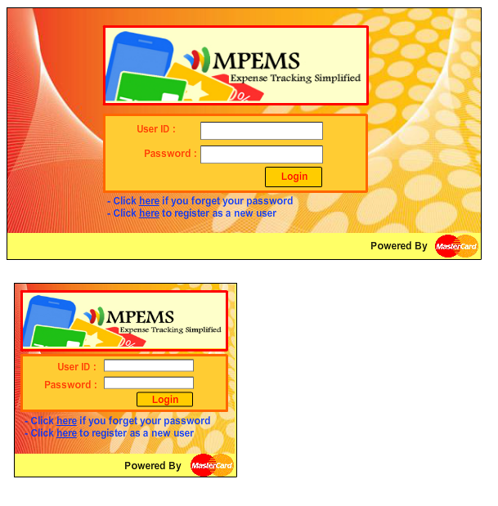

2.2 User Screen Menu
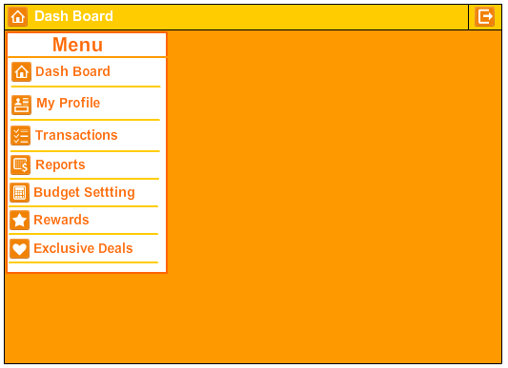

2.3 Dash Board

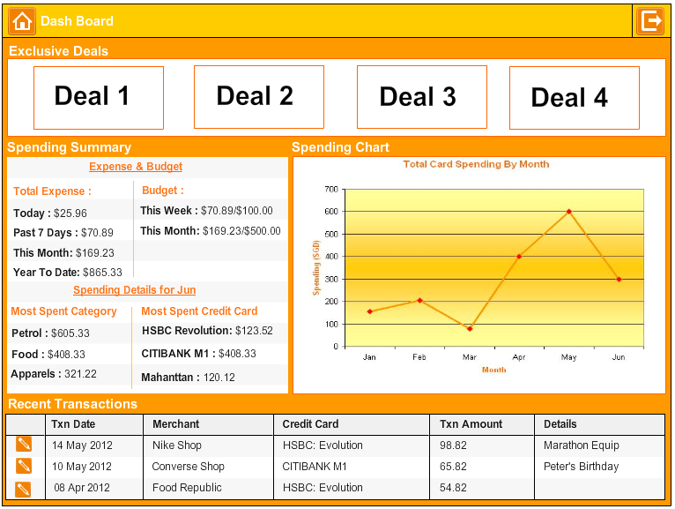

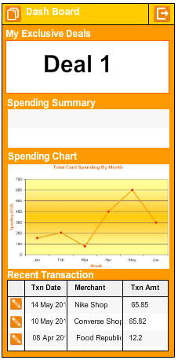

2.4 My Profile
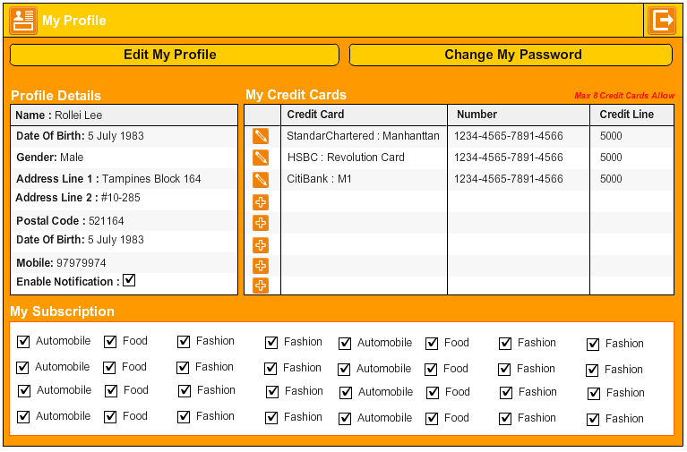

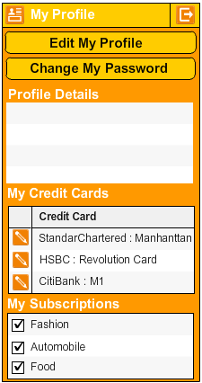

2.5 Transaction

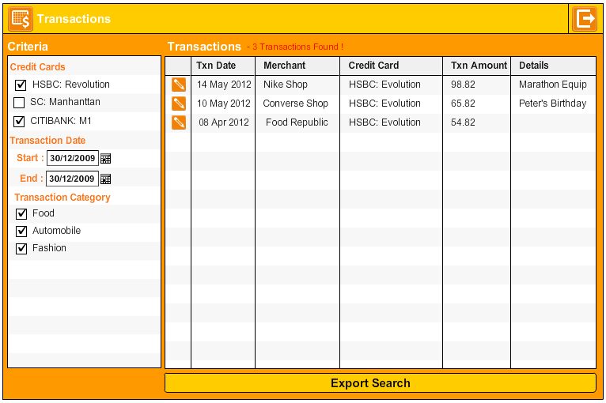

2.5 Reports

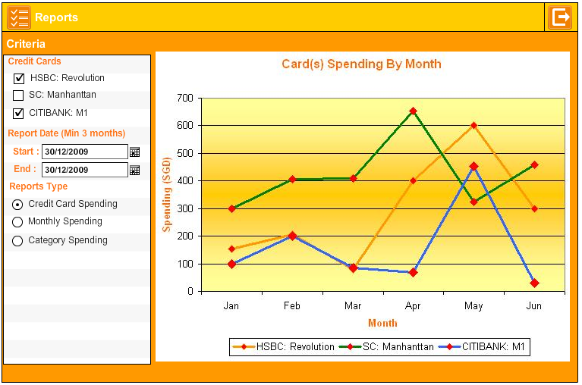

2.6 Budget Setting

2.7 Rewards

2.8 Exclusive Deals

3. Administrator Screens

4. Amendment History

Version | Section | Remarks
v0.1 | 18 May 2012 | Initial Draft

